**Huawei Certification Written Exam Guide (iLearningX)**

**2020**



Huawei Technologies Co., LTD.

Contents

 1

1 Overview of Huawei Certification Written Exam Guide 1

2 Registering a Huawei Account 2

2.1 Registering a Huawei Account 2

2.2 FAQs About Huawei Accounts/Passwords 3

3 Scheduling a Huawei Certification Written Exam 3

3.1 How to Schedule an Exam on Website 3

3.2 Re-scheduling/Cancellation 6

4 Paying the Written Exam Fee 7

5 Taking the Written Exam 7

5.1 Introduction to the Written Exam Process 7

**5.1.1 Preparations and Precautions** 7

**5.1.2 Start the Exam** 8

5.2 Admission Rules for Written Exam 10

5.3 Troubleshooting 10

6 Obtaining Huawei Technical Certificate 10

6.1 Obtaining an e-Cert 11

6.2 Obtaining the HCIE Package 11

7. Huawei Certification Examination Score/Certificate Management 13

Associating Huawei Certification Records 13

# Overview of Huawei Certification Written Exam Guide

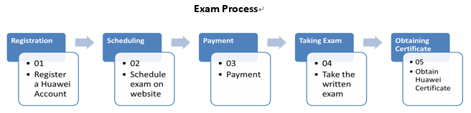

note

* Application Sessions

Huawei Certification written exam is delivered by Pearson VUE, please click [here](https://e.huawei.com/cn/talent/#/cert/rules) for the examination process. If you were invited by Huawei to take the exam and have an authorization Code , please register the exam on the webpage. These sessions which is not available to the general public, are available on an invitation-only basis and often associated with classroom training , special testing events or The local Pearson VUE test center closed. If you don’t have an authorization Cod, please contact your invigilator or local Huawei training manager.

* *Exams can only be scheduled using your verified Huawei account.*
* Exam Requirements

|  |  |  |
| --- | --- | --- |
| Category | No. | Description |
| Basic Environment Requirements for Examination Rooms | 1 | Enclosed, independent, clean and comfortable environment. |
| 2 | Adequate lighting and ventilation; |
| 3 | Internet access is available in the exam room. It is recommended that the network speed be greater than 1M/s |
| Seat Requirements | 4 | Comfortable seats and workbenches (suggest 1.2 m long and 0.6 m wide); |
| Examination computer | 5 | The examination room must be equipped with a computer with a keyboard and mouse. The requirements for the computer are as follows:  a. It is recommended that the computer Operating system: Windows 7 or later,be configured with a quad-core 2.0 GHz CPU, 8 GB memory, and a monitor resolution of higher than 1920 x 1080 .  b. Please use version 58.0 or higher of Google Chrome browser during the exam. Other browsers (such as Edge, Firefox, etc.) will be incompatible.  c. A functional camera is required.  d. It is not recommended to use the corporate network (including the VPN). It is recommended to use the external network. e. You are not advised to use a working computer to prevent your computer from identifying related software. f. Before the exam, close apps that may display pop-up messages, such as chat software, email, Office software, translation software, alarm software, and forcible screen saver software. The maximum number of screen switching times is 5. When the number of screen switching times reaches the maximum, the system automatically rewinds the volume.  g. Ensure you are connected to a power source before starting your exam to avoid draining your battery during the exam |

*Test requirements: Please login to the test link at least 1 day before the exam and feedback to examiner if there is any problems. During the formal exam, if there is unexpected screen switching happened due to Internet, browser or software, the exam will not be reopen for free.*

Test link: <https://ilearningx.huawei.com/portal/exam/100720/about>

Registration (Skip This Step If You Have a Huawei Account.)

Visit Huawei official website and register an account.

Scheduling

A candidate can schedule an exam in the following way:

Website: Visit the Huawei website to schedule an exam. For details, click Scheduling an Exam on Websites.

Payment

You can only pay the exam fees by exam voucher for iLearningX exam.

Voucher: You can obtain written exam vouchers from Huawei regional training manager/Huawei local exam contact.

note

*Any valid vouchers can only be used once and should be used to finish exam before expired date. Vouchers become invalid once expired.*

Taking the Written Exam

After you have successfully scheduled an exam, you must to login to the exam link to take the exam at the specific time. After you finish the exam, the exam page will show your scores online.

Obtaining Huawei Certificate

If you have passed Huawei certification, you will receive an email notification of "e-Cert Download" sent by Huawei within one working day after completing the exam. You can download the e-Cert by following the instructions in the email or on [Huawei website](https://e.huawei.com/cn/talent/#/admin/mycertificate).

# Registering a Huawei Account

## Registering a Huawei Account

Visit Huawei website. After the [login and application](https://uniportal.huawei.com/) page is displayed, enter information as prompted and submit the information, as shown in the following figure.

note

*Please creating an account with email.*

*When creating an account, use your real name, which must be the same as that on your certificates.*

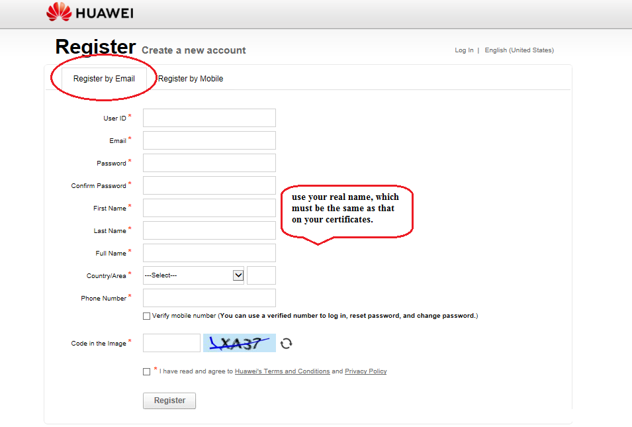

Activate the account. After your information is submitted, the system automatically sends an activation link to your mailbox specified during registration.

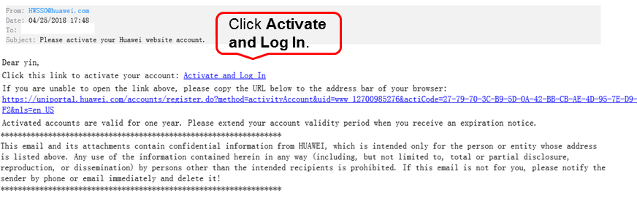

## FAQs About Huawei Accounts/Passwords

For more FAQs about Huawei accounts and passwords, visit the Huawei Website [Account Help Directory.](https://uniportal.huawei.com/uniportal/help_en.html?ver=v3r29)

Back to Overview of Huawei Certification Written Exam Guide

# Scheduling a Huawei Certification Written Exam

## How to Schedule an Exam on Website

Please apply your exam from Huawei local exam contact or Huawei regional training manager first. You can make an appointment for the exam only after receiving the exam authorization code.

Huawei Certification written exam is delivered by Pearson VUE, please click [here](https://e.huawei.com/cn/talent/#/cert/rules) for the examination process. If you were invited by Huawei to take the exam and have an authorization Code , please register the exam on the webpage. These sessions which is not available to the general public, are available on an invitation-only basis and often associated with classroom training , special testing events or The local Pearson VUE test center closed.

Exam appointment link：[https://e.huawei.com/en/talent/#/admin/myappointments/invitation](https://e.huawei.com/en/talent/" \l "/admin/myappointments/invitation)

note

*If you have participated in Huawei certification exams, use the original Huawei account. Otherwise, you may fail to obtain a new certificate.*

*Please prepare the computer for the exam. Before scheduling the exam, ensure that you have installed the required software.*

*Please complete the test before scheduling the exam to ensure that you meet the exam requirements. Huawei will not re-arrange the exam for free and the exam fee will not be refunded If the exam fails due to unqualified network and computer hardware configuration and software.*

*Exam Requirements*

1. Login to the [Exam appointment link](https://e.huawei.com/cn/talent/#/admin/AppointmentsAdd) and read the instruction on header for Career certification exam carefully. Check your personal information, and click “Edit” if it needs to be modified.

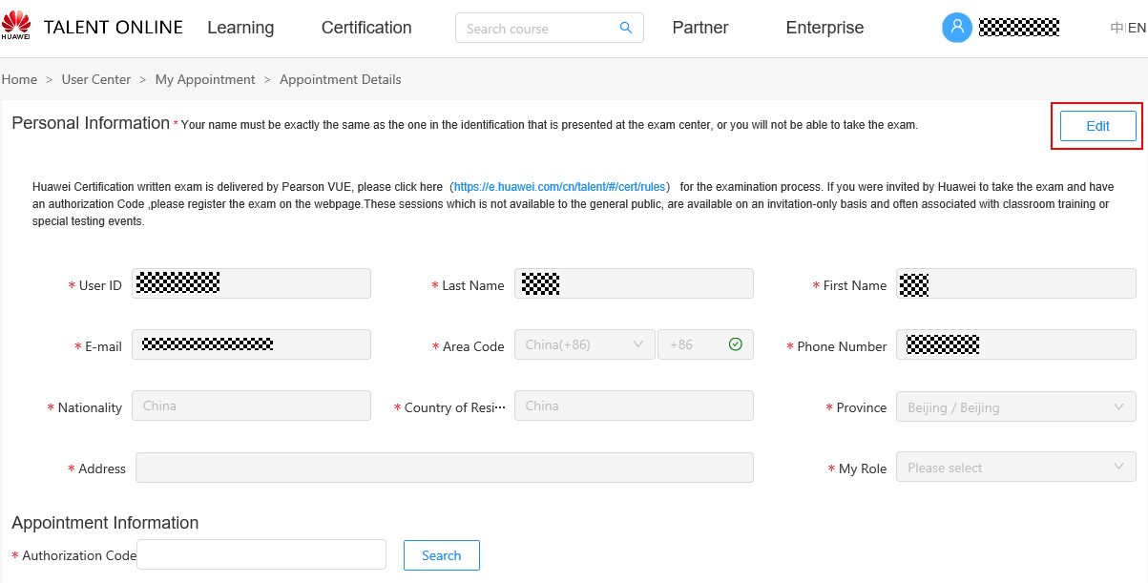

1. Fill in your information, and click “Save”.

[NOTE]

**Full Name**: Please use your real name which is the same as the one on your ID card, or you cannot take the exam. The name will appear on your certificate.

**E-mail**: Please fill in the email address of the registered account, and verify it is available. This email address will receive your registration notification emails and certificates.

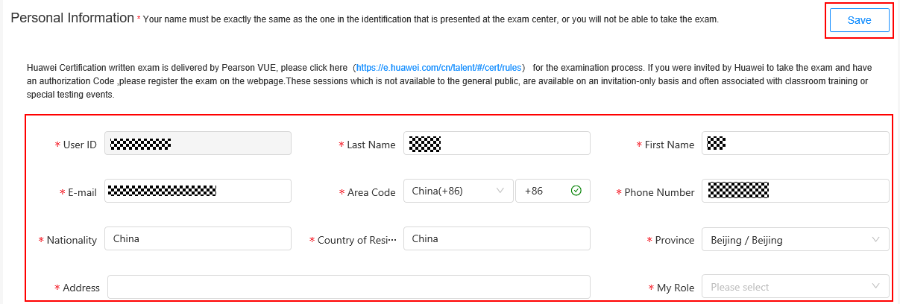

1. On [Appointment Details page](https://e.huawei.com/cn/talent/#/admin/AppointmentsAdd) , input Authorization Code (Get from your Huawei regional training manager/Huawei local exam contact), click “Search”, then select Language and Session.

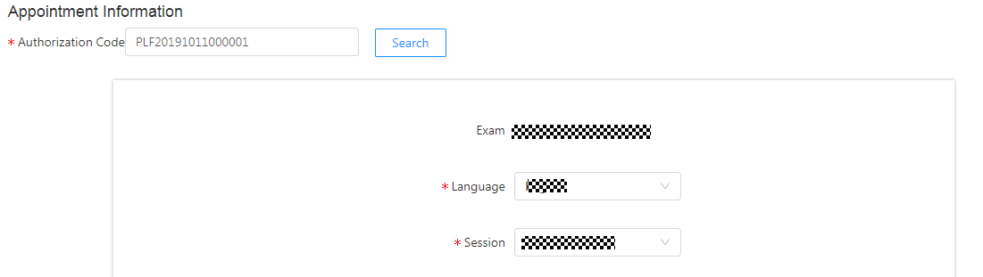

1. Payment: Please input valid Voucher No. before submit.

If an error occurs, please check if you input a wrong number; otherwise, please contact your voucher issuer/institution to get a valid voucher.



1. Check the exam information carefully, then click “Submit”.

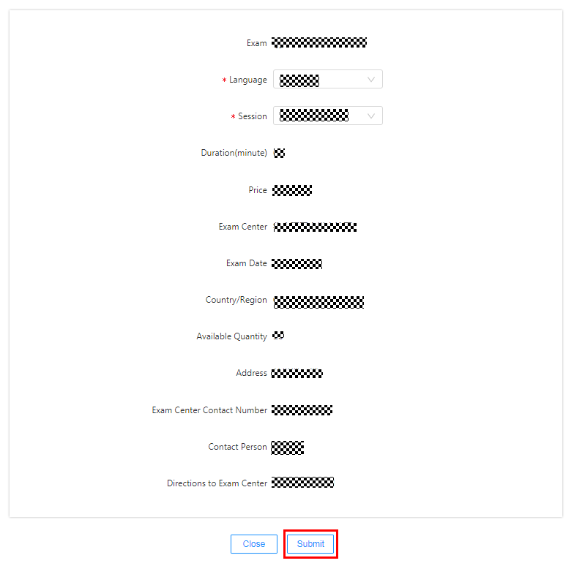

1. After submitting, you can check your Appointment information on [My Appointment page](https://e.huawei.com/en/talent/#/personal/myappointments/list).

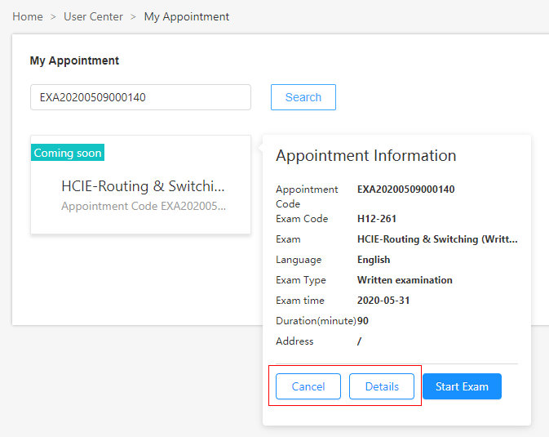

## Re-scheduling/Cancellation

Exams must be rescheduled or canceled at least 5 days before the scheduled exam time. Exam fees cannot be refunded if you fail to reschedule or cancel less than 5 days in advance, or if you fail to take the exam by the scheduled start time.

1. **Cancel an exam:**

Log in to the Huawei website, you can check your appointment information on [My Appointment page](https://e.huawei.com/en/talent/#/personal/myappointments/list). Select the exam that needs to be canceled, and click “Cancel” as prompted.



The rule for exam fee refunding is as follow:

If you use an exam voucher to pay the exam fee, the exam voucher is released immediately after the exam is canceled, and can be used to schedule a new exam.

1. **Change the time of an exam:**

To change the exam date, please contact your Huawei local exam contact or Huawei regional training manager in advance to ensure that you can make an appointment for the exam on the current day.

.

Back to the Guide to Huawei Certification Written Exam

# Paying the Written Exam Fee

You need to pay the exam fees when scheduling an iLearningX exam in the following way:

**Exam voucher**: You can pay using an exam voucher when you schedule an exam online.

**Rules for using Huawei exam vouchers:** An exam voucher can be used to schedule an exam specified by the voucher. The exam voucher is not registered or refundable and cannot be extended or redeemed for cash. The validity period is one year (for special exam vouchers, the validity period is calculated based on the original settings). If an exam is canceled, the exam voucher will be released. You can schedule a new exam but you need to complete the exam within the original validity period.

You can obtain or purchase a voucher from Huawei regional training manager/Huawei local exam contact.

Back to the Guide to Huawei Certification Written Exam

# Taking the Written Exam

## Introduction to the Written Exam Process

* + 1. **Preparations and Precautions**

**Test requirements:** Please login to the test link at least 1 day before the exam. If there is any problems, please feedback to examiner. During the formal exam, if there is any unexpected screen switching due to Internet, browser or software, the exam will not be reopened for free.

Test link: <https://ilearningx.huawei.com/portal/exam/100720/about>

**Exam Requirements:**

|  |  |  |
| --- | --- | --- |
| Category | No. | Description |
| Basic Environment Requirements for Examination Rooms | 1 | Enclosed, independent, clean and comfortable environment. |
| 2 | Adequate lighting and ventilation; |
| 3 | Internet access is available in the exam room. It is recommended that the network speed be greater than 1M/s |
| Seat Requirements | 4 | Comfortable seats and workbenches (suggest 1.2 m long and 0.6 m wide); |
| Examination computer | 5 | The examination room must be equipped with a computer with a keyboard and mouse. The requirements for the computer are as follows:  a. It is recommended that the computer Operating system: Windows 7 or later,be configured with a quad-core 2.0 GHz CPU, 8 GB memory, and a monitor resolution of higher than 1920 x 1080 .  b. Please use version 58.0 or higher of Google Chrome browser during the exam. Other browsers (such as Edge, Firefox, etc.) will be incompatible.  c. A functional camera is required.  d. It is not recommended to use the corporate network (including the VPN). It is recommended to use the external network. e. You are not advised to use a working computer to prevent your computer from identifying related software. f. Before the exam, close apps that may display pop-up messages, such as chat software, email, Office software, translation software, alarm software, and forcible screen saver software. The maximum number of screen switching times is 5. When the number of screen switching times reaches the maximum, the system automatically rewinds the volume.  g. Ensure you are connected to a power source before starting your exam to avoid draining your battery during the exam |

* + 1. **Start the Exam**
* **Check**

1. Log in to WeLink according to the <WeLink video conference operation guidance>. (Skip this step for non-remote exams. The meeting link will be sent to the email address reserved for candidates one day before the exam. Please check it carefully.)
2. Cooperate with invigilator to complete on-site recording.



* **Take the exam**

1. Open and login to [my appointment](https://e.huawei.com/en/talent/#/personal/myappointments/list) page, find the corresponding appointment on exam date , or search the appointment code/exam code , then click ”Start Exam” at the specified time.

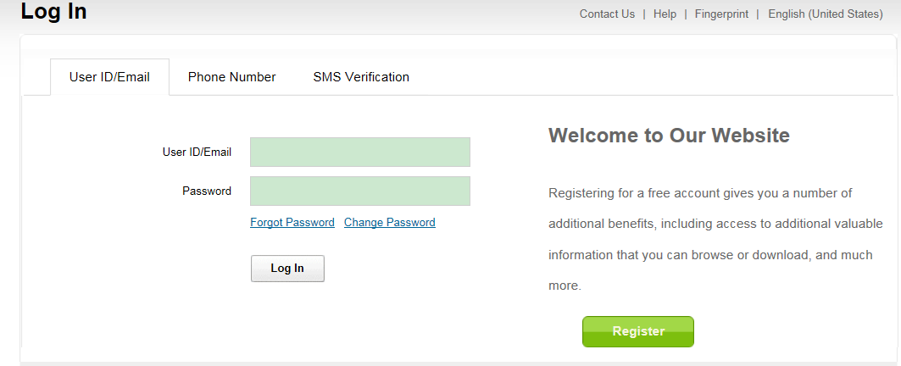

**If you forgot the password，**

**Please click here**

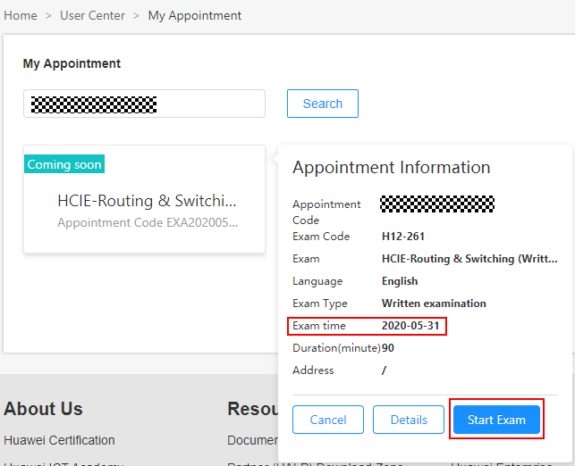

1. Click “Start Exam”. (If you cannot find any exam information, or exam information is incorrect, please feedback to your examiner.)

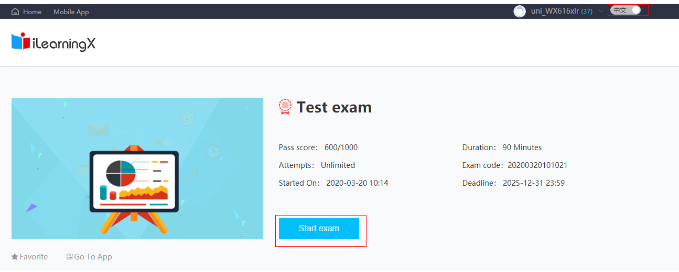

1. Please confirm your personal information. (Please confirm that your name is correct, it will appear on the certificate.)

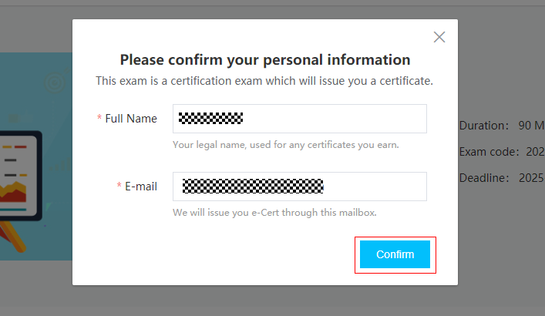

1. After the exam is completed, click "Submit" in the upper right corner.

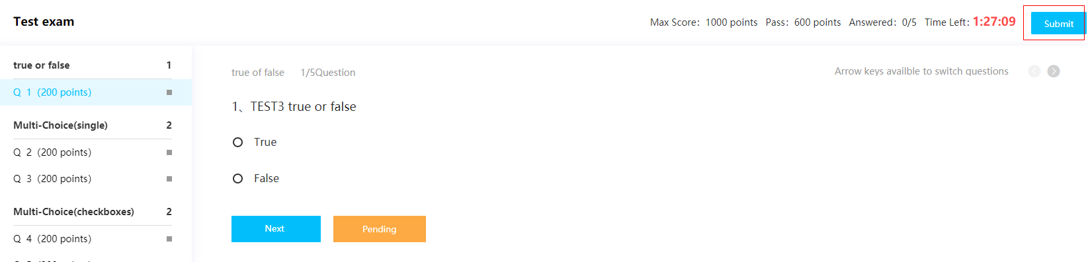

1. Check the Answer Card, and click “Confirm”.

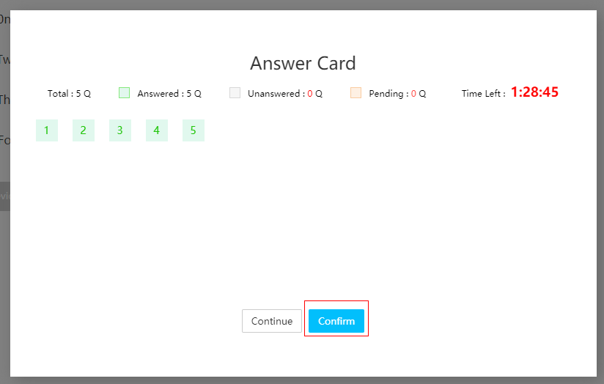

1. Check your exam result.

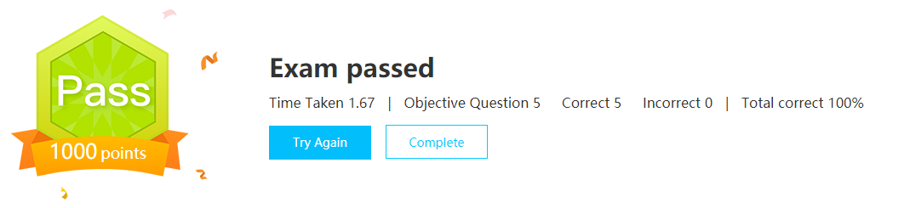

## Admission Rules for Written Exam

* Log in to the conference link at least 30 minutes in advance to ensure that you have enough time to complete necessary programs. (Ignore this step if the test is not conducted remotely.)
* You need to provide your ID card or a valid identity certificate (temporary ID card or passport within the validity period) issued by the public security bureau to take the exam. Other certificates are invalid. The original certificates must be valid and within the validity period (photocopy is not allowed). Huawei will check the qualification before starting the exam, exam fees will not be refunded if you are disqualified due to non-compliance of your certificates.
* Candidates are not allowed to block the computer cameras without authorization. The exam system will automatically capture the images of the computer cameras during the exam and detect any violations.
* Do not install any software irrelevant to the exam. Answer the questions in strict accordance with the exam system. If you fail to answer the questions as required, you will be liable for any loss incurred.
* Candidates must complete the exam by themselves. During the exam, they must keep quiet and must not peek at any materials (such as mobile phones and books) except the test computer screen.
* Candidates are not allowed to leave the exam for any work or other reasons irrelevant to the exam. The exam can be ended only after the answers are uploaded.
* Huawei will strictly keep the exam content confidential. It is prohibited to record the exam content through audio recording, screen recording, or taking notes. It is also prohibited to discuss, communicate, or disclose the exam questions after the exam.
* If an examinee fails to pass an exam, he/she has to take the exam after seven days. If an examinee passes an exam, he/she has to take the exam after 30 days.

## Troubleshooting

Any unexpected condition happen, perform the following operations:

* Technical fault: If technical faults such as network disconnection, power failure, and computer breakdown occur during the exam, contact the exam administrator. If the technical fault cannot be rectified, the exam administrator will create an incident report for you. You can contact your Huawei regional training manager/Huawei local exam contact to apply for exam time change or exam cancellation.
* Screen switching and paper submission caused by unstable network, browser or software during the exam will not be handled.

Back to the Guide to Huawei Certification Written Exam

# Obtaining Huawei Technical Certificate

From November 1, 2018, Huawei provides only e-Certs (except for HCIE certificates). To download a Huawei e-Cert, visit [Huawei e-Cert](https://e.huawei.com/cn/talent/#/admin/mycertificate) a working day after the exam day.

Candidates who have passed the HCIE certification exam can visit Huawei training and certification website to maintain their address information three working days after receiving the score reports. After seven working days, they can click [Huawei Certificate](http://support.huawei.com/enterprisemysupport/mysupport#click=mycertificates) Link to query the mailing information.

## Obtaining an e-Cert

Log in to Huawei Training and Certification website, enter your personal account, choose [**Home** > **User Center** > **My Certificate**,](https://e.huawei.com/cn/talent/#/admin/mycertificate) and click the corresponding certificate name to download the e-Cert, as shown in the following figure.

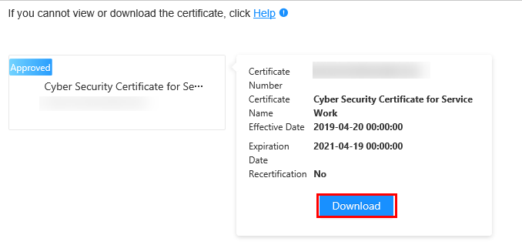

## Obtaining the HCIE Package

1. Visit Huawei Training and Certification website and choose [**Home** >**User Center >My Certificate**](https://e.huawei.com/en/talent/#/personal/mycert).

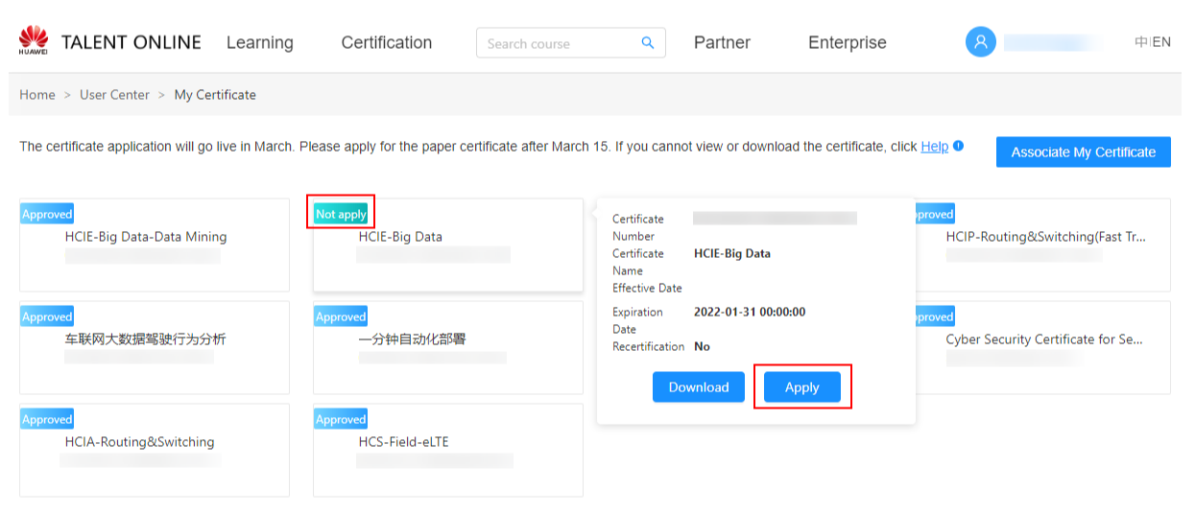

2. On “My Certificate” page, choose the certificate that you **not apply** yet, and click “**Apply**”.

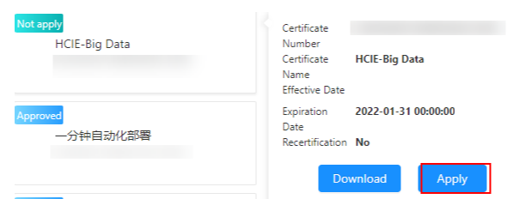

1. Fill in the certificate mailing information, then click “**submit**”.

( Make sure that the full name on the electronic certificate you downloaded is correct. If you have any questions, please contact [Certification@huawei.com](mailto:Certification@huawei.com) to confirm or modify and then apply for your certificate. Please note that once submitted successfully, your paper certificate will be to made and cannot be changed.)

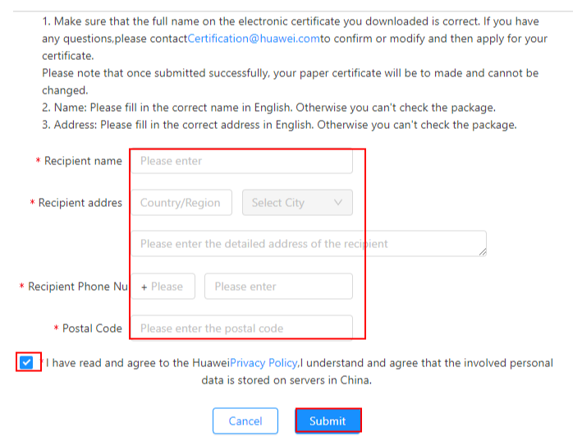

1. Huawei will mail the HCIE package in five to seven working days and send the express order number to your email through Certification@huawei.com.
2. You can also visit your personal space on Huawei Training and Certification website ([**Home** >**User Center >My Certificate**](https://e.huawei.com/en/talent/#/personal/mycert).) to query the mailing process: choose your certificate that was “**Approved**” and click “**View application progress**”.

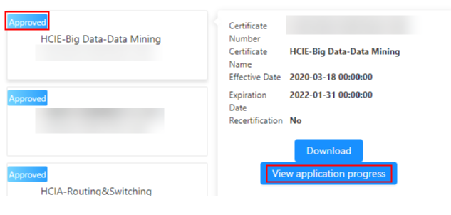

If the mailing progress is “**To be updated**”, the HCIE package has not been mailed yet.

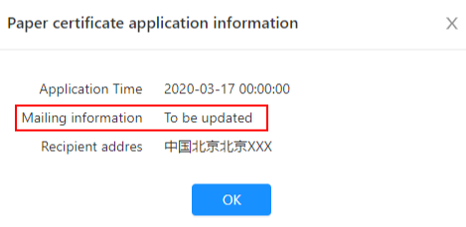

Back to the Guide to Huawei Certification Written Exam

# Huawei Certification Examination Score/Certificate Management

* **One account for all Huawei certification exam results**: You must associate all your exam scores with the same account. Otherwise, you may not be able to obtain a specific certificate. For details, see the following section "Scenario 1: Associating Huawei Certification Records".
* **Your personal account for Huawei certification exam results**: If your Huawei account is associated with an exam record of another person, the account must be unbound. Otherwise, the system will forcibly unbind the exam record. For details, see the following section "Scenario 2: Unbinding Huawei Certification Exam Records".

## Associating Huawei Certification Records

Intended audience: Huawei certification candidates

●

note

* *Your Huawei account can only be associated with your own certification exam results.*

**Associating Your Mailbox with Your Account**

If a message is displayed indicating that your email address has been associated with an account, click **OK**,log in to the associated mailbox, and click the activation link to complete the association.

Access path: [**Huawei Training and Certification Website** > **User Center** > **My Certificate** > **Associate My Certificate**](https://e.huawei.com/cn/talent/#/admin/mycertificate).

After the association request is submitted, the system automatically sends an activation email.

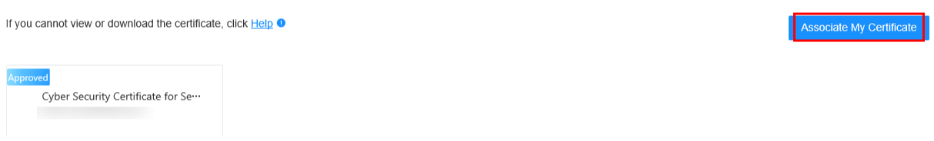

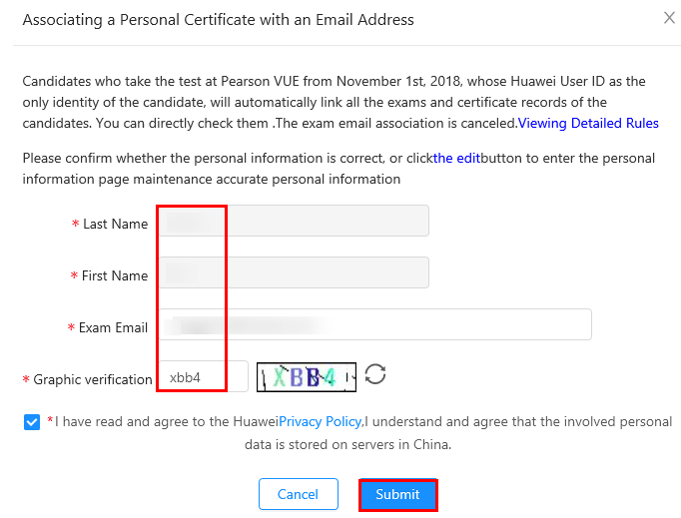

Log in to your mailbox and click the activation link.

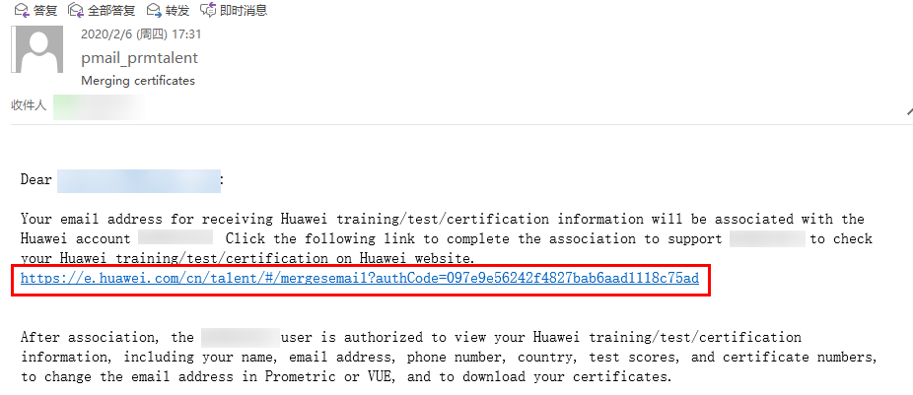

For more questions, send an email to Certification@huawei.com for consultation.